How to Enter in A Ticket
Go to https://servicedesk.mt.gov. (production site)
Under the State Financial Services section, there are two boxes Procurement Requests and Procurement Issues that you can select to submit a request/ticket.
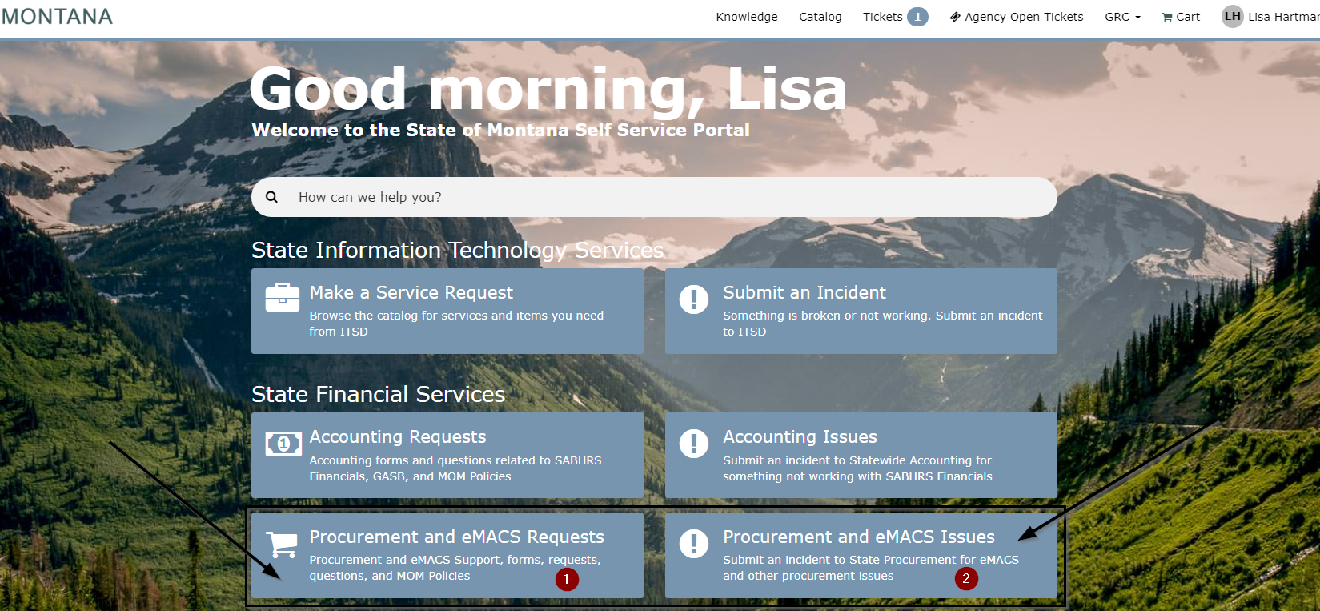
Once you select Procurement and eMACS Requests you will be redirected to the SPB Catalog. There are two different views, see images below:
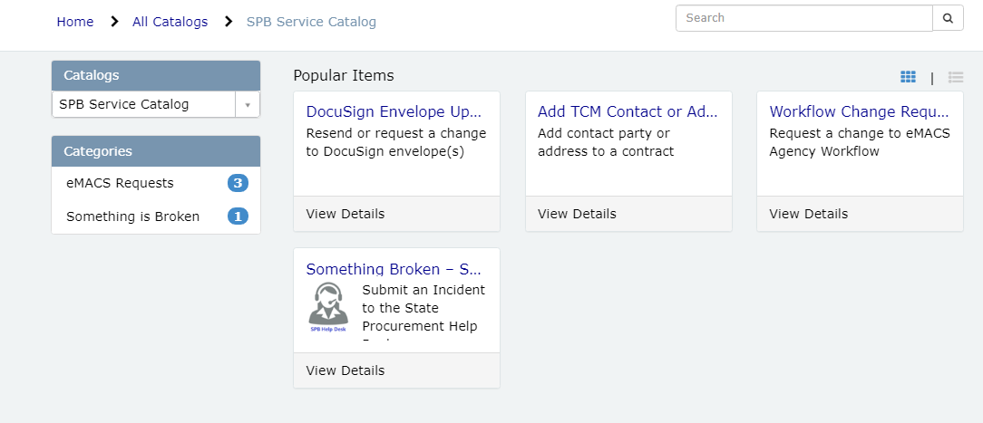
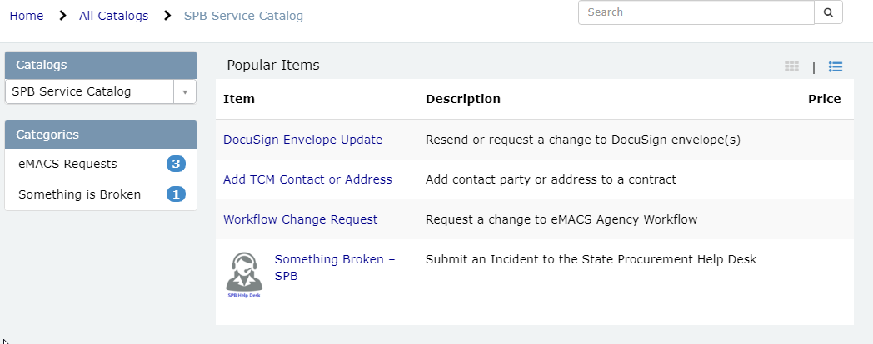
Select the request needed, if it is not showing up, Select Something Broken-SPB.
From there complete the whichever form you have chosen for your request.
____________________________________________________________________________
If the box links are not working here is an alternative way to access the SPB Catalog:
Up on the menu bar, select Catalog
Use the dropdown menu to find SPB Service Catalog.
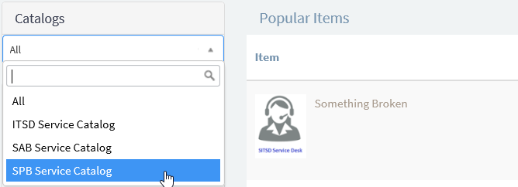
Select “eMACS Requests” and then select the request type needed.
Note: There are two different views when you look at Popular Items.
Fill out the form with the required information.

